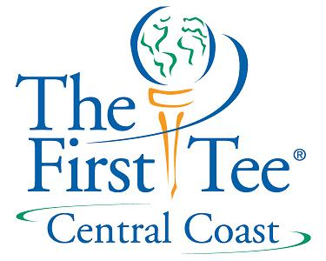

Fund Raising Module #2

Who Contributes??

- Classes of contributions
  - 72% - individuals
  - 15% - foundations
  - 8% - bequests
  - 5% - corporations
- Donor Development Process
  - Cultivation
    - process of developing prospects
  - Solicitation
    - asking!!
  - Stewardship
    - thank you
    - what happened to their money
    - keeping donor retention

“People give money to people who support worthy causes”

