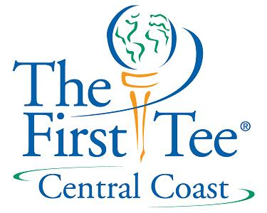

Fund Raising Module #3

4 legged stool of Fund-Raising
DONOR

Annual Major Capital Planned
Funding Gifts Campaign Giving

- Board Progression in Fund-Raising
  - board must reach out to the public

Public Friends
Friends Donors
Donors Fund-raisers

“People give money to people who support worthy causes”

