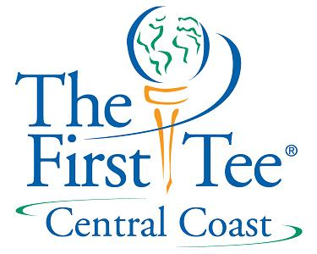

Fund Raising Module #4

Things to Remember!!

The number #1 reason people do not donate to your
organization is that they were not asked.
******
Involvement invites investment.
******
The Board must role model “giving behavior” for other
prospects and donors to follow.
******
All fundraising is local.
******
No organization owns a donor.
******
No donor gives away his or her last $500 or ($5,000)
******
You seldom get more than you ask for.
******
Fundraising is about building and maintaining relationships-
it is a marathon, not a sprint.

“People give money to people who support worthy causes”

