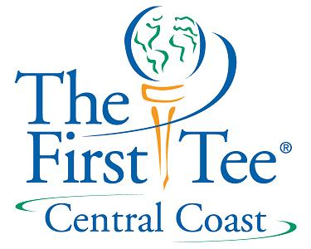

Fund Raising Module # 5
Board Member Activities

Turn 10 Individuals Each Year into “Friends”
********
Call Donors to Thank Them for Their Gifts
*******
Donate to the Best of Your Ability
*******
Identify and Recruit Future Board Members
********
Speak Frequently About Your Organization
********
Identify Contacts in Private and Family Foundations
********
Host Cultivation and Stewardship Events

“Spheres of Influence”

#3
#2
#4
#1

