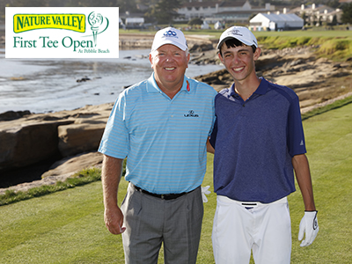 | THE FIRST TEE  CENTRAL COAST  Honesty Integrity Sportsmanship Respect  Confidence Responsibility Perseverance Courtesy Judgment

Board of Directors  Dr. Robert Moss, Chairman  Matt Porter, Vice Chairman  Lori Vereker, Secretary  Greg Siadal, Treasurer  Nicki Anderson  Barbara Kummer  Mia Cameron  Sheila Davidson  Josh Heptig  Whitt Hollis  Matt Lane,DDS  Bonnie Lauer, LPGA  Randy Shannon, PGA  Andrew Sherman  Carrie Wood  Ambassador Council  David Alpert  Darren Avrit  Dr. James Benzian  David Blaemire  Joe Bush  Andy Chou  Andrew Chung  Jean Conway  Ron Cossa  Tony Cossa  Linda DeTarr  Ed Edick  Geoff Fargo  Jeff Forster  Carol Frazzano-Bailey  Don Gragg  David Gronsky  Granville Harper  Ed Murray  Eddie Murray  Tim Nightingale  Earl Severo Jr  Jerry Pimm  Gary Setting, PGA  Gary Simpson  Staff  Jessani Johnson  Executive Director  Butch Breeden  Development Director  Billy Gibbs, PGA  Program Director  Terri Benson, PGA  Mike Brabenec, PGA  Doug Crane, PGA  Jim DeLaby, PGA  Billy Gibbs, PGA  Julia Puscheck, PGA  Bonnie Lauer LPGA  Kyle Marme PGA  Darren Avrit  Paige O’brien PGA  Lori Vereker  Connor Chartier  Matt Cradduck, PGA  Rory Doll, PGA | NOTICE & AGENDA FOR THE FIRST TEE CENTRAL COAST  BOARD OF DIRECTORS – REMOTE BOARD MEETING  Thursday August 13th, 2020  Noon, Via Zoom.us Meeting ID# 853 6747 1045 Password: 426668  - Introductions / Fundraising  - Welcome & Introductions (Jess & Rob)  - Board Tracking Sheets (Jess)  - Case for support (Butch)  - Reports/Discussions  - Strategic Plan Update (Jess)  - La Cumbre Golf Tournament / and replacement fundraising ideas (Butch/Jess)  - Summer Programming Report / Fall Tentative Schedule (Billy)  - PPP Loan update (Jess)  - Action Items  - Consent Agenda  - Minutes from May 14, 2020 meeting  - 7/31/2020 P&L & Balance Sheet  - New Business  - Benchmarking (Jess/Rob)  - Old Business  - Golf Mania Fundraiser Update (Butch)  - Safesport Background Checks & Safety Training Requirements (Jess/Billy)  - Announcements  - Remaining 2020 Meetings:  - Joint Meeting SMCC – November 12, 2020  - Strategic Plan Meeting 4-8pm Location TBD
  OUR MISSION: To impact the lives of young people in Santa Barbara, Ventura, and San Luis Obispo counties by providing educational programs that build character, instill life-enhancing values and promote healthy choices through the game of golf.

